Standard | Items:
K.0A.02  Solve addition and subtraction word problems, and add and subtract within 10, e.g., by using objects or drawings to represent the problem. T3 | 3.0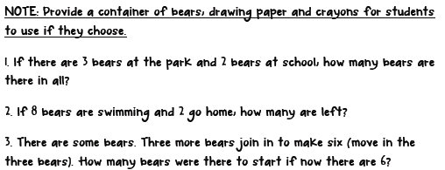
 | 2.0
K.0A.03  Decompose numbers less than or equal to 10 into pairs in more than one way, e.g., by using objects or drawings, and record each decomposition by a drawing or equation (e.g., 5 = 2 + 3 and 5 = 4 + 1). T3 | 3.0  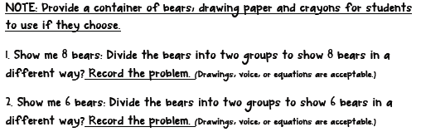
 | 2.0
K.OA.04 -  For any number from 1 to 9, find the number that makes 10 when added to the given number, e.g., by using objects or drawings, and record the answer with a drawing or equation. T3 | 3.0  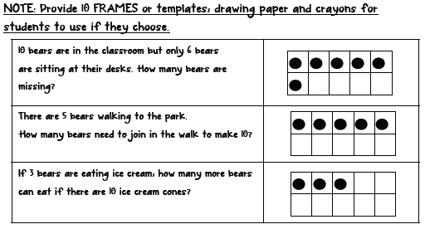
 | 2.0
K.NBT.01 -  Compose and decompose numbers from 11 to 19 into ten ones and some further ones, e.g., by using objects or drawings, and record each composition or decomposition by a drawing or equation (e.g., 18 = 10 + 8); understand that these numbers are composed of ten ones and one, two, three, four, five, six, seven, eight, or nine ones several measurable attributes of a single object. T3 | 3.0  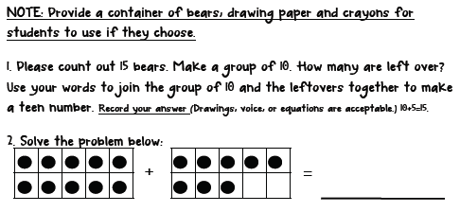
 | 2.0

